# Five9 CCaaS Troubleshooting Guide

Reminders

MGR

Clearing Your Cache

Five9 Softphone System Check – Internal Users

Logging In to Five9 – Internal Users

Logging Out of Five9 – PeopleSafe Users

Headset and Audio Troubleshooting

The Connectors Button:

Check Headset Compatibility:

Checking Your Physical Headset:

How Do I Resolve the Echo on My Phone or Check for Audio Issues?:

I Have Muted My Phone and the Caller Can Still Hear Me:

What Should I Do If I Cannot Hear a Member? What Should I Do If the Member Says They Cannot Hear Me?:

Adjusting Microphone Volume Settings:

Adjusting Headset Volume Settings:

Checking Sound Device Settings:

Testing Speaker Functionality:

Setting Your Audio Device:

Check and Adjust Sound Settings in Five9

Changing Not Ready Reason Code States

Transfer and Conference FAQs

PeopleSafe FAQs

PeopleSafe Users: CTI Pop-up, Authenticated and Non-Authenticated Calls

My E911- For Internal Colleagues ONLY

Resetting Your Supervisor Station ID for Supervisor Plus

Network Quality Icon Is Red or Yellow

WiFi Usage

Audio Troubleshooting Scenario Guide

WebRTC Troubleshooting Scenario Guide - Vendor

Related Documents

**Description:** Resolution steps for common issues related to the Five9 applications.

|  |
| --- |
| Reminders |

If, after triaging the issue, it is still not resolved, escalate to your leader.

If your leader is unavailable, escalate to the manager on duty. The leader or manager will determine if this is a single-user issue or involves multiple users requiring escalation to the CMO Incident Management team.

|  |
| --- |
| MGR |

When Five9 emergency changes and/or maintenance is needed, it may be referred to as an “MGR”. If you are informed by your leader of an MGR, refer to [Five9 MGR User Guide (063780)](https://thesource.cvshealth.com/nuxeo/thesource/#!/view?docid=9c55c4f7-dd7c-413d-a53c-c0a3c1990f6e) for how the changes will impact you and steps that should be taken.

Top of the Document

|  |
| --- |
| Clearing Your Cache |

When is it proper to clear my cache (and cookies)?

* Do not clear your cache when you are actively on a call using Five9, as closing your browser would disconnect you from your softphone and cause the call to drop. Clear cache once your call is no longer active.
* Anytime you are experiencing an issue with a Five9 application.

 It is important the full process be followed as listed below, including closing all browsers after clearing your cache has been completed.

Complete the following steps to clear cache:

|  |  |
| --- | --- |
| **Step** | **Action** |
| **1** | Log out of Five9 first, then log out of other applications (Compass, PeopleSafe, etcetera).  **Note:** CVS users may need to submit a Workbrain correction to update payroll. |
| **2** | Close all web browser windows and refer to [Clearing Your Cache (008655)](https://thesource.cvshealth.com/nuxeo/thesource/#!/view?docid=cd7acfcb-ad36-4da3-b973-faf08afb7dea).  Failure to close all browsers means that all cache may not be cleared. |
| **3** | Once cache is cleared, attempt to re-launch Five9.  If these steps do not resolve the issue, restart the system. |

Top of the Document

|  |
| --- |
| Five9 Softphone System Check – Internal Users |

If you are experiencing issues logging into Five9, ensure that you have both the:

* Five9 Softphone Service Software installed on your desktop and
* Five9 Softphone Extension installed on your Chrome browser.

Refer to the following screenshots to check you have the necessary applications installed.

**Five9 Softphone Service Software – Desktop Installation:**

* On your Start menu, navigate to your list of folders and applications. A Five9 folder should appear with the service software included in the folder.

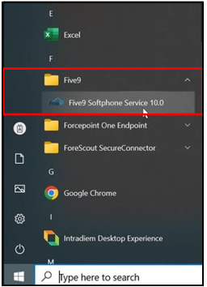

* Alternative Option: Check your Taskbar tray for a Five9 Softphone icon.

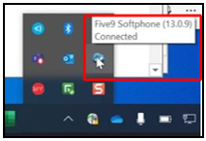

* Alternative Option: Check your Desktop icons for either Five9_Supervisor_SSO or Five9 ADT_SSO.

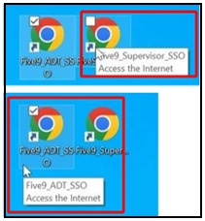

* Alternative Option: Open the desktop application **CVS Health CSI** and navigate to the **Installed Software** tab, checking for the Five9 software. Applicable to internal colleagues only.

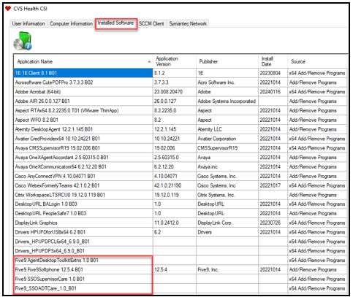

**Note:** The Desktop Icons are shortcuts to launch the respective Five9 Software (Five9_ADT_SSO for Agents and Five9_Supervisor_SSO for Supervisors).

You can launch the Five9 software using the URLs in the Login Instructions (linked below) if the Desktop Icons are not visible. However, you must have the Five9 Software service installed on your machine for the desktop for the URLs to work.

* [PeopleSafe - Log In and Log Out of the Five9 Soft Phone (052163)](https://thesource.cvshealth.com/nuxeo/thesource/#!/view?docid=9546ff42-1c20-43e0-8a1f-bd8a5408de5b)
* [LDR: Five9 Login Instructions for Supervisor (Internal Colleagues Only) (052166)](https://thesource.cvshealth.com/nuxeo/thesource/#!/view?docid=17d5cfb2-954e-412b-973d-62bb8fe89e34)

**Five9 Softphone Extension – Chrome Browser:**

* Navigate to the top right corner of your browser and click on the **puzzle piece icon**.

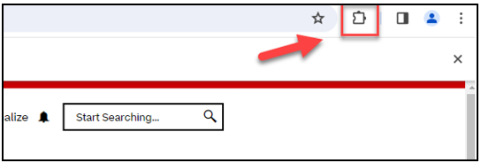

* A drop-down menu with extensions should appear with Five9 Softphone Extension included.

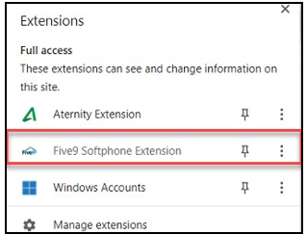

Top of the Document

|  |
| --- |
| Logging In to Five9 – Internal Users |

If you continue to experience login issues after validating that you have the Five9 software AND the Five9 Chrome Extension, try the following:

* For CVS users, have you successfully logged into Five9 using SSO in the past?
  + If yes, clear your cache and try logging in again. A restart may also be needed.
  + If no, reach out to your leader to confirm that you have been provisioned.

You may also receive the “Download and Install Software” message when attempting a softphone login, even after successfully logging into Five9 in the past. This can occur even if you have the software and browser extensions, as sometimes this occurs upon login when the softphone is not running in the background.

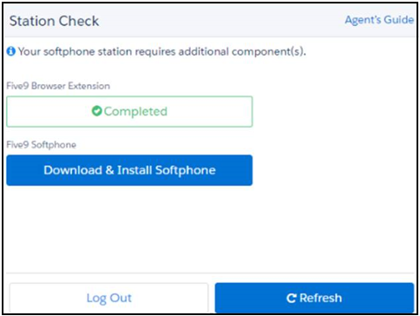

To resolve this, complete the following steps:

|  |  |
| --- | --- |
| **Step** | **Action** |
| **1** | Locate the Five9 Softphone application in the Search bar in the Start Menu and select **Open**.    **Result:** You will not see anything open on your screen; but the softphone is being activated in the background. |
| **2** | Return to the Five9 Softphone and select **Refresh**. |
| **3** | Attempt to complete the login process by proceeding through the Station Setup.     * If you have followed these steps, including clearing cache, and re-starting, and are still experiencing this error, reach out to your supervisor to submit a ticket to the CMO Colleague Support team. |

Top of the Document

|  |
| --- |
| Logging Out of Five9 – PeopleSafe Users |

**Example: I am getting an error that my username and password is not correct.**

If you log out of Five9, you will be brought to a login page that requires Five9 credentials. Care users do not have Five9 Credentials; Five9 log in is SSO based. Follow the steps below if a re-login is needed:

* Close the browser completely.
* Re-log in. Refer to the following Work Instructions applicable to your role as needed:
  + [PeopleSafe - Log In and Log Out of the Five9 Soft Phone (052163)](https://thesource.cvshealth.com/nuxeo/thesource/#!/view?docid=9546ff42-1c20-43e0-8a1f-bd8a5408de5b)
  + [PeopleSafe - Log in Steps for Five9 WebRTC via VDI and Citrix – Vendor (074280)](https://thesource.cvshealth.com/nuxeo/thesource/#!/view?docid=e82b072b-62cf-4a2d-aa6f-6145ed6da720)
  + [LDR: Five9 Login Instructions for Supervisor (Internal Colleagues Only) (052166)](https://thesource.cvshealth.com/nuxeo/thesource/#!/view?docid=17d5cfb2-954e-412b-973d-62bb8fe89e34)
  + [LDR (Vendor Only): Five9 Soft Phone, Supervisor Desktop Plus, Aceyus, and Verint Login (073893)](https://thesource.cvshealth.com/nuxeo/thesource/#!/view?docid=ad6447f4-61ac-423c-9983-44e8164c9e1e)
* If this does not resolve the issue, then clear cache before trying to log in again. A restart may also be needed.

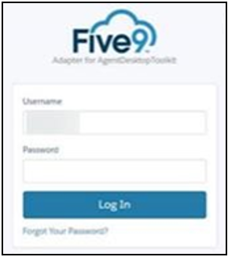

Top of the Document

|  |
| --- |
| Headset and Audio Troubleshooting |

Refer to as needed:

The Connectors Button:

Check Headset Compatibility:

Checking Your Physical Headset:

How Do I Resolve the Echo on My Phone or Check for Audio Issues?:

I Have Muted My Phone and the Caller Can Still Hear Me:

What Should I Do If I Cannot Hear a Member? What Should I Do If the Member Says They Cannot Hear Me?:

Adjusting Microphone Volume Settings:

Adjusting Headset Volume Settings:

Checking Sound Device Settings:

Testing Speaker Functionality:

Setting Your Audio Device:

### The Connectors Button:

**Do not** use the Connectors button in the Five9 Phone. The button was previously used to report sporadic audio issues, but the process has now changed, and it should no longer be used for this. Review this guide and work with your supervisor to troubleshoot audio issues. If unable to resolve, the supervisor will need to submit a ticket to the CMO Colleague Support team.



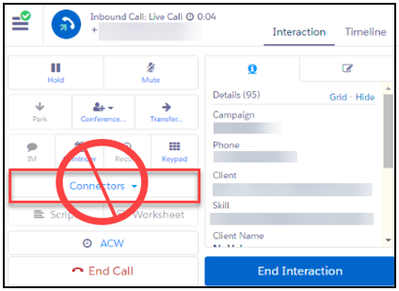

Return to Headset and Audio Troubleshooting

### Check Headset Compatibility:

If you are having trouble with your headset, confirm your headset is compatible with Five9.

* USB headsets are Five9 compatible.
* Generally, wireless headsets are NOT Five9 compatible.
* Please notify your supervisor or manager if you have audio issues using your current headset.

Check to see if you can hear audio on another application to confirm if Five9 is the issue or if the issue is the headset itself. If the issue is with your headset, contact your leader to have your headset replaced.

Return to Headset and Audio Troubleshooting

### Checking Your Physical Headset:

Complete the following steps:

|  |  |
| --- | --- |
| **Step** | **Action** |
| **1** | Check if the headset is detected via the Sound Control Panel.   1. Right click on the Volume icon and select **Sounds**.      1. Click **Recording**.     **Result:** The headset should be listed.   * If the headset is not detected, unplug it, and then plug it back in.   + If the headset is still not detected, try using a different USB port.     - If you continue to have audio issues using your current headset, notify your supervisor or manager. |

Return to Headset and Audio Troubleshooting

### How Do I Resolve the Echo on My Phone or Check for Audio Issues?:

If experiencing Audio Issues or if you hear an echo on the line, refer to the Audio Troubleshooting Scenario Guide.

 **Do not** troubleshoot while on an active call with a member.

Return to Headset and Audio Troubleshooting

### I Have Muted My Phone and the Caller Can Still Hear Me:

Your headset in Five9 should be set up as follows:

* Output: Headset Earphone (Jabra EVOLVE LINK MS)

**Note:** Select the proper headset earphone. Your headset may be labeled differently.

* Input: Headset Microphone (Jabra EVOLVE LINK MS)

** Do not** select “Speakers (Realtek (R) Audio)” as the Output setting.

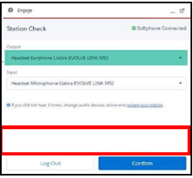

Return to Headset and Audio Troubleshooting

### What Should I Do If I Cannot Hear a Member? What Should I Do If the Member Says They Cannot Hear Me?:

Refer to as needed:

* Adjusting Microphone Volume Settings
* Adjusting Headset Volume Settings
* Checking Sound Device Settings

If this information does not help, contact your local IT desk for further help.

Return to Headset and Audio Troubleshooting

### Adjusting Microphone Volume Settings:

Complete the following steps:

|  |  |
| --- | --- |
| **Step** | **Action** |
| **1** | Start by navigating on your computer to **Start > Settings > System > Sound**. |
| **2** | Select the **headset** to use with the Five9 Softphone. |
| **3** | Click **Device Properties**. |
| **4** | Adjust **Microphone Levels**. |

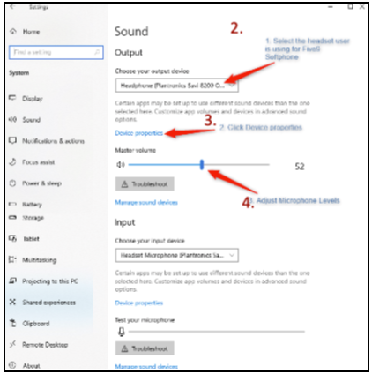

Return to Headset and Audio Troubleshooting

### Adjusting Headset Volume Settings:

**Note:** You MUST launch and login to the Five9 Phone for it to show up in the application list.

Complete the following steps:

|  |  |
| --- | --- |
| **Step** | **Action** |
| **1** | Start with the headset in use with the Five9 Phone. |
| **2** | Click **Advanced Sound Options**. |
| **3** | Check the **volume levels** for Five9 Phone. |

Return to Headset and Audio Troubleshooting

### Checking Sound Device Settings:

Complete the following steps:

|  |  |
| --- | --- |
| **Step** | **Action** |
| **1** | Check if the headset is set to the default device.   1. Right click on the **Volume** icon and select **Sounds**.      1. Click **Recording**.   **Result:** The headset should be listed. |
| **2** | Confirm if the Microphone properties do not have the setting “Listen to this device” enabled.  **Note:** When this checkbox is selected, the computer will listen to your microphone and play the input sound to the playback device selected.  **Examples:**   * If the device selected is your computer speaker, whatever the microphone captures will get played back in the speaker. * If the device selected is the headset, it will cause the sound to be played back to your headset and the agent will be able to hear their voice but not the other party. This sound can only be heard in the playback device tool and not in the recording of the call. |
| **3** | Under the **Sounds** tab, ensure **Windows Default** is selected and not “No Sounds”. |
| **4** | Ensure audio is not on mute.   1. Under **Recording**, select the **Microphone** and click on **Properties**. 2. On the Microphone Device window, go to **Levels** and check if the audio is on mute. Also, check if the headset has a built-in Mute function.      1. Check the headset microphone if it works via the built-in Voice Recorder. This app should allow you to record your voice. If there is no playback, go ahead with the next steps.      * If your microphone is not working, go to **Settings > Privacy > Microphone**.   + Ensure “Allow apps to access your microphone” is set to **On**.   **Note:** If microphone access is **Off**, all applications on your system will not be able to hear audio from your microphone.   * + Scroll down to “Allow desktop apps to access your microphone”, ensure Five9 Softphone shows “Currently in use”, and relaunch Five9 Softphone Service 10.0. |
| **5** | Go to App volume and device settings by going to **Settings > System > Sound > Advanced Sound Options**.   * Check the default audio output / input set for the Softphone and select **App Volume and Device Preference**. |
| **6** | Be sure to disable **Exclusive Mode**. Exclusive Mode allows applications to take exclusive control of the interface so that other apps cannot play sound at the same time. This may cause issues when switching audio apps or when another application is also running.   1. Go to **Sound**. 2. Click on the **active audio device in use**. 3. Click **Advanced** and disable Exclusive Mode.        * 1. **Note:** Changes to the sound device’s configuration may result in temporary loss of audio. This is a design behavior windows and may vary per device. It is advisable that as soon as the changes are performed, relaunching the apps, unplugging, and plugging the audio device, or restarting the station in Five9 should re-establish the audio connection. |

Return to Headset and Audio Troubleshooting

### Testing Speaker Functionality:

Complete the following steps:

|  |  |
| --- | --- |
| **Step** | **Action** |
| **1** | Check if the headset is set to the default device for the speaker.   1. Right click on the **Volume** icon and select **Sounds**.      1. Click **Playback**.   **Result:** The headset should be listed and set as Default Device. |
| **2** | Under **Playback**, select the **Speakers Headset**, then right click and select **Properties**. |
| **3** | Go to the **Enhancements** tab and confirm that “Disable all enhancements” is not enabled. |
| **4** | Check audio is not on mute and volume level. |
| **5** | * Go to the **Levels** tab and check if the audio is on mute. * Check **Speakers** volume level and increase if needed.     **Note:** If you experience an uneven volume on your headset (**Example:** Left speaker is louder than right speaker), press the **Balance** button as seen in the photo above to attempt to fix this issue. |
| **6** | When all settings are good, click the **OK** button to save any changes made. |
| **7** | At the **Playback** tab, right-click on the **Speakers** of the headset and click **Test**.  **Result:** You should hear a sound on the headset playing.   * If no sound is heard on the headset after clicking **Test**, please notify your supervisor or manager. |

Return to Headset and Audio Troubleshooting

### Setting Your Audio Device:

Click the **Headseat** at the bottom of the Five9 Adapter.

**Result:** Audio settings display.

Confirm Audio Output, make changes as needed, and select **Done**.

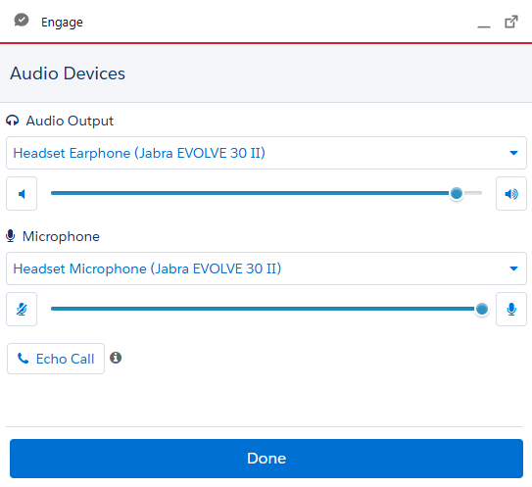

Return to Headset and Audio Troubleshooting

Top of the Document

|  |
| --- |
| Check and Adjust Sound Settings in Five9 |

If incoming calls are received and a beep or whisper is not heard, complete the following steps:

|  |  |
| --- | --- |
| **Step** | **Action** |
| **1** | Ensure you are in Not Ready state. If not, select **TEC – System or Technical** with leadership approval. |
| **2** | Select **Settings**. |
| **3** | Select **Sounds Alerts**. |
| **4** | Ensure **all boxes** are checked:   * If any boxes are unchecked, check them. |
| **5** | Select **Save & Close**. |
| **6** | Return to **Ready** and resume taking calls or normal duties.    **Note:** If agent still does not hear a beep or whisper when receiving a call (traditional inbound or call back), work with your supervisor to follow the below troubleshooting steps:   * Clear the browser cache and restart the CPU. * Repeat steps to validate sound settings. * If settings are correct and the issue persists, leaders should engage with the [LDR: Submitting Requests to Colleague Support (068644)](https://thesource.cvshealth.com/nuxeo/thesource/#!/view?docid=9ed28fb8-dffe-4c71-91fb-1a8b556ed2a0) team to open an intake ticket. |

Top of the Document

|  |
| --- |
| Changing Not Ready Reason Code States |

**I am not able to change my Not Ready Reason Code.**

After a call has been completed and if you cannot change the Not Ready Reason Code, try the following steps:

|  |  |
| --- | --- |
| **Step** | **Action** |
| **1** | Completely log out of Five9. |
| **2** | Clear Cache. |
| **3** | Log back in to Five9.   * If the issue persists, contact your supervisor to submit a ticket with the CMO Colleague Support team. |

Top of the Document

|  |
| --- |
| Transfer and Conference FAQs |

**How do I exit the call when performing a warm transfer or warm conference?**

**Warm Transfer:** Select **Complete Transfer** to move your caller to the next agent.

**Result:** This will also remove you from the call. You will then be placed back into your previous state, which will be a “Ready State”, unless you have proactive changed your state before completing the transfer.

**Note:** If you have proactively changed your state, your softphone will show your state as “Pending”, followed by the selected Not Ready Reason Code, and once the transfer is complete, you will move to that Not Ready status.

**Conference:**

* If you do not need to conference the member in with you and the next agent, simply select **Cancel** to disconnect from the next party and return to the member.
* If you have conferenced in the member with you and the next party/agent, then there are several options for exiting the call:

1. **Leave Conference** will remove you from the call but allow the member and the next party/agent to continue to speak.
2. **End Call** or **End Interaction** will end the call for all parties.
3. You can select **Remove** to remove the second party/agent and keep you and the member on the call together.

**When to use Conference / Transfer:**

* Whether you intend to transfer the member or not, anytime you need to reach out to another party, use Conference or Transfer. Both processes will automatically place the member on hold when you make outreach to the next party.
* Do not use **Hold** for this reason.
* **Warm Conference** is our business standard as it allows you to both brief the next agent before the conference and introduce both parties when the calls are merged. It should always be used unless the process states otherwise or specifically to use a **Cold Transfer**.

Top of the Document

|  |
| --- |
| PeopleSafe FAQs |

**Why am I getting a PeopleSafe Session Time Out error?**

PeopleSafe will still time out after 30 minutes of inactivity.

If you receive a timeout message when you have not been inactive for that amount of time, then this can indicate an issue that is not related to the PeopleSafe timeout.

There are two potential causes for this:

1. **For Internal Users only, check for browser mismatch:** For Internal PeopleSafe users, this application must be opened in Microsoft Edge. The system default browser should also be set to Microsoft Edge. Although Five9 should be opened in Chrome (always use the desktop icon if available), having your system default browser set to Chrome will cause this browser mismatch, resulting in not receiving CTI pop-ups and receiving a PeopleSafe timeout error.

**Solution:** Ensure that your system default browser is set to Edge, but that Five9 opens in Chrome.

1. **Five9 domain selection:** Check to ensure that the correct domain is selected in Five9, which matches the domain noted in PeopleSafe. If it is incorrect, it may cause a PeopleSafe timeout error.

**Solution:** Confirm the domain and update Five9 if needed.

Top of the Document

|  |
| --- |
| PeopleSafe Users: CTI Pop-up, Authenticated and Non-Authenticated Calls |

Upon a system start, you will briefly see a black box come up, which is associated with the CTI software package installed. This should disappear once your system is fully loaded. If it does not, navigate to Colleague Zone to open an IT Ticket. You may need to have a newer CTI software package installed. If you are not receiving CTI pop-ups, then not having the necessary software, or having outdated software, may be the cause.

**How the CTI Works for PeopleSafe Users with Five9:**

* For IVR authenticated calls, the CTI pop-up will launch automatically in PeopleSafe with the member’s information, along with confirmation that the member is fully authenticated with the verbiage “IVR Authenticated” on the CTI pop-up. A new PeopleSafe tab is automatically loaded, opening with the member’s information. You should not select “get call information” to load the members information as this does not work in Five9. The member’s profile should automatically load.
  + If the call is fully authenticated but there is no CTI pop-up, view the toolbar and see if there is a white box with a black circle. When present, this indicates that the caller authenticated through the IVR, and if flashing, this means that the CTI pop-up is there but has not been clicked on.
  + Click on the flashing icon (the white box with the black circle in the toolbar) to view where the CTI pop-up displays on your screen. It may be popping up behind other browsers. Rearrange your screens so that you can always view the CTI pop-up and be fully aware of the member’s information.



* + The softphone has the option of selecting “Open CTI”. This will re-launch the CTI pop-up; however, it will also re-launch the member’s information in a PeopleSafe browser. Avoid selecting Open CTI if the member’s information has already loaded in PeopleSafe for this reason.

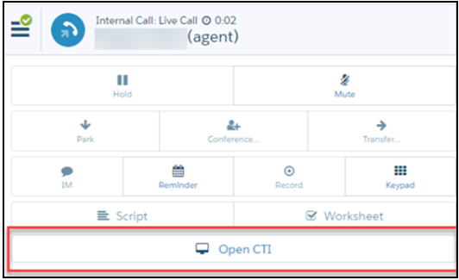

**Reminder:** If you are not receiving any CTI pop-ups then check the following areas:

* + - Confirm that the domain selected in the Five9 Softphone matches the domain noted in PeopleSafe.
    - For Internal users, ensure that your system browser is set to Microsoft Edge and that PeopleSafe is also opening in Microsoft Edge.
      * If you are still not receiving CTI pop-ups, then reach out to your supervisor to have a ticket submitted with the CMO Colleague Support team.
* For non-IVR authenticated calls, there will **not** be a CTI pop-up.
  + When this call type occurs, a new PeopleSafe tab will be launched on the Member Search screen, allowing you to manually collect and enter the member’s information.

Top of the Document

|  |
| --- |
| My E911- For Internal Colleagues ONLY |

Only those that are work-from-home (not working onsite) will be required to enter their physical location. When working onsite your location is detected automatically. Follow the instructions outlined in [Five9 E911 Device Registration (052184)](https://thesource.cvshealth.com/nuxeo/thesource/#!/view?docid=7e7e0fcf-59eb-4bc1-8a1b-cd91ee386e99) to set up E911.

Once you have registered your E911, if it is not saving your location and you are being prompted to re-enter and/or re-save it after locking or re-starting your PC, please report this to ITSC and open a ticket.

**Reminders:**

* Anytime your WFH location changes to another WFH location, you must update your address to reflect the new location.
* You should not need to update it if going onsite as onsite locations are set to be automatically detected and updated. If you are onsite and the onsite location is not updating automatically, open a ticket with ITSC.

Top of the Document

|  |
| --- |
| Resetting Your Supervisor Station ID for Supervisor Plus |

Supervisors are assigned a Station ID to use in Supervisor Plus. Supervisors should not enter the Station ID when setting up the Five9 Phone, as that is automatically generated.

If you incorrectly enter your assigned Supervisor Plus Station ID into the phone, follow the below steps to reset your Supervisor Station ID:

|  |  |
| --- | --- |
| **Step** | **Action** |
| **1** | Log out of Supervisor Plus and the Five9 Phone. |
| **2** | Log into the Five9 Phone.   * When you get the request for Phone / Station ID at Station Setup, clear out the Station ID field, and then select **None** to login without a Station ID.   **Note:** You should not be logged into Supervisor when performing this step. |
| **3** | Complete the login to the softphone.  **Note:** There is no need to go into “Ready” state. |
| **4** | Once logged in, log out of the softphone. |
| **5** | Clear the Chrome cache and cookies. |
| **6** | Close out Chrome completely, making sure all Chrome windows are closed. |
| **7** | Launch the softphone again.  **Note:** It should default back to the **None** option for Station Setup. |
| **8** | Change option back to **Phone / Station ID**.  **Result:** You should see a new number assigned to Station ID.  **Reminder:** This is automatically generated in the phone, so you should not need to note this down or keep track of it. |
| **9** | Log in as normal. |

Top of the Document

|  |
| --- |
| How to Clear Cached Five9 Station ID |

Follow the steps below:

|  |  |
| --- | --- |
| **Step** | **Action** |
| **1** | Click the 3 dots in the upper right corner of the browser. |
| **2** | Click **Settings**    **Result:** Settings screen displays. |
| **3** | Click **Reset settings**.    **Result:** Reset Settings banner displays. |
| **4** | Click on the **Restore Settings to their original defaults** banner.    **Result:** Reset Setting pop up displays.  Click **Reset settings**. |
| **5** | Closethe browser and Re-launch Five9/Supervisor Plus. |

Top of the Document

|  |
| --- |
| Network Quality Icon Is Red or Yellow |

The Network Quality Icon is an indicator of the health of your web browser. When the Network Quality Icon is yellow or red, there are browser constraints such as bandwidth or memory that may impact the performance of Five9.

Work with your supervisor to complete the following steps to troubleshoot the issue:

|  |  |
| --- | --- |
| **Step** | **Action** |
| **1** | Close any unneeded browser tabs. |
| **2** | Check if your computer shows that desktop memory is low. |
| **3** | Check your network speed while connected to the VPN.   * Navigate to speedtest.zscaler.com to test your network speed. * Document the following should the issue continue and your results match what is required in the following areas: Ping, Jitter, Download and Upload results.   + Requirements:     - Ping: 200 ms or less     - Jitter: 40 ms or less     - Download: 8 Mbps or greater   + If your results do not meet the above requirements, contact your Internet Service Provider (ISP) to triage and address what requirements are not met.   + If your results do meet the above requirements and your network speed continues to be low, disconnect from the VPN, and test your network speed again at speedtest.zscaler.com. If the speed is significantly faster, the network slowness is likely on the CVS side and may not be related to your ISP. Note that disconnecting from the VPN will disconnect your softphone; CVS internal users may need to enter a Workbrain correction for payroll reasons. Supervisor should submit a ticket with the CMO Colleague Support team. |

Top of the Document

|  |
| --- |
| WiFi Usage |

The Five9 Phone does not work well when using Wi-Fi, and it is required that a hard-wired connection be used. If you are experiencing Phone slowness, audio issues, etc. , confirm that you are hard wired connected and not on WiFi.

**A wired connection is required for the Five9 Phone.**



If you are not using a Five9 Phone but are using other Five9 applications and are experiencing issues, you should also switch to a hard-wired connection.

Top of the Document

|  |
| --- |
| Audio Troubleshooting Scenario Guide |

Refer to the table below:

|  |  |  |  |  |
| --- | --- | --- | --- | --- |
| **Audio Issue** | **Troubleshooting Step 1** | **Troubleshooting Step 2** | **Troubleshooting Step 3** | **Troubleshooting Step 4** |
| **Unable to hear 3 tones after Five9 log in.**    Confirm if you do not have Five9 audio or you are just not hearing the 3 tones. If you determine that you have Five9 audio connection, then it is okay that you do not hear the 3 tones. | Restart station in Five9. | Check audio settings in Five9 to confirm the input/output is correct.    If a webcam is plugged in, it is possible that this may be the cause, as Five9 may be pulling audio from the webcam. Unplug the webcam and determine if this resolves the issue. | Check your audio settings in Five9 by selecting the Headphone icon at the bottom of Five9.    Next, select the Echo Call button.    Instructions will be given on speaking a message that will be played back. At the sound of the beep, speak into Five9 and wait for it to repeat it back.    If this does not work, try rebooting the physical desktop and try again. | Make an outbound call to confirm if audio is working from both sides.  If issues persist, have your supervisor submit a ticket to CMO Colleague Support team.  **Supervisors:** Refer to [LDR: Submitting Requests to Colleague Support (068644)](https://thesource.cvshealth.com/nuxeo/thesource/#!/view?docid=9ed28fb8-dffe-4c71-91fb-1a8b556ed2a0). |
| **Being placed in "System" Not Ready Code.**    This indicates that the audio connection with Five9 is broken.    This will not be resolved by changing back to Ready state. Audio must be restored. | Select the Five9 indicator at the bottom left of the phone, indicated by circle with a check mark in the middle.   * **Green Indicator** – Successful Audio Connection * **Red Indicator** – Audio is not connected. Click the indicator from the disconnected message, click the option to re-connect.   A screenshot of a phone  AI-generated content may be incorrect. | Check audio settings in Five9 by selecting the Headphone icon.  A screenshot of a computer  AI-generated content may be incorrect.  Next, select the Echo Call button.    Instructions will be given on speaking a message that will be played back. At the sound of the beep, speak into Five9 and wait for it to repeat it back.    If this does not work, try rebooting the physical desktop and try again. | Make an outbound call to confirm if audio is working from both sides. | If issues persist, have your supervisor submit a ticket to CMO Colleague Support team.  **Supervisors:** Refer to [LDR: Submitting Requests to Colleague Support (068644)](https://thesource.cvshealth.com/nuxeo/thesource/#!/view?docid=9ed28fb8-dffe-4c71-91fb-1a8b556ed2a0). |
| **Checking for Audio issues or Hearing an Echo** |

Top of the Document

|  |
| --- |
| WebRTC Troubleshooting Scenario Guide - Vendor |

WebRTC refers to the **vendor only** Five9 login process.

Refer to the table below:

|  |  |  |  |  |
| --- | --- | --- | --- | --- |
| **WebRTC Issues** | **Troubleshooting Step 1** | **Troubleshooting Step 2** | **Troubleshooting Step 3** | **Troubleshooting Step 4** |
| **Citrix URL is not loading** | Confirm correct Citrix link is being used:   * **Compass:** https://remote.caremark.com * **PeopleSafe:** https://secureapps.cvshealth.com | Confirm it is being used in a new browser, rather than being used within a browser on the non-secure apps Citrix URL previously used. | Ensure the correct browser is being used. Chrome browser is preferred. Edge can be used as a backup option. Internet Explorer is not supported. | N/A |
| **Cannot log into Citrix** | Confirm correct credentials are being used, and user is not locked out.  Username begins with either the C or Z ID. Lock out occurs after 3 failed attempts and to unlock, user must call CVS IT. | Symantec VIP token must be downloaded and registered in advance. In addition, token must be associated with users CVS CaremarkRX account. Follow the below steps, and if unresolved, contact CVS IT.  The steps are outlined in [Downloading and Logging in with the Symantec VIP Application (028464).](https://thesource.cvshealth.com/nuxeo/thesource/#!/view?docid=83e355b3-1518-4c17-a857-8998e4d9b6c4)  To register your Symantec VIP token, refer to [Registering and Using Your Token to Login to Cisco AnyConnect and CVS Health MFA (043627)](https://thesource.cvshealth.com/nuxeo/thesource/#!/view?docid=239f8bde-d8ea-497d-88b9-3adbe48edce6). | **PeopleSafe users only:** Confirm domain selected is CaremarkRX.  **Compass users:** Not applicable. | N/A |
| **Unable to log into Five9, including SSO Credential not being recognized** | Users logging into Five9 via the Compass integrated phone, ensure that "SSO Log In" is being selected.  For PeopleSafe users, Five9 automatically logs in the user using SSO Login.  **Note:** After logging out of Five9 the browser opens to a screen requiring a Five9 log in. Vendor users no longer have Five9 log in credentials, they must close the browser and re-launch the Five9 phone shortcut to initiate the Five9 SSO log in process. Refer to Logging Out of Five9 - PeopleSafe Users. | Clear cache and cookies, close browsers, and re-launch. | If when trying to log into Five9 you are getting an error and your vendor email address is what is in Five9, manually change the email to your CVS email address.  **Steps:**  1.Select the arrow to the left of the vendor email credentials.   * If the CVS email credential is listed, select the CVS email and then select **Next**. * If you **do not** see your CVS email: Select log in with other user. Then manually type your CVS email and then select **Next**.  1. **Enter** the password associated with your network login (i.e. what is used for Citrix). 2. Select **Sign in**. | If issues persist, have your supervisor submit a ticket to CMO Colleague Support team.  **Supervisors:** Refer to [LDR: Submitting Requests to Colleague Support (068644)](https://thesource.cvshealth.com/nuxeo/thesource/#!/view?docid=9ed28fb8-dffe-4c71-91fb-1a8b556ed2a0). |
| **Cannot open the Service 360 Sycurio – Azure (Compass) app.**    Users may be receiving “Windows can’t open this type of file (.ica) or any other download error. | This requires the user to contact their respective IT department to enable permissions on the desktop. | N/A | N/A | N/A |
| **Station Setup screen does not display in Five9** | Clear cache and try to log in again. | If issue persists, restart the CPU. | If issues persist, have your supervisor submit a ticket to CMO Colleague Support team.  **Supervisors:** Refer to [LDR: Submitting Requests to Colleague Support (068644)](https://thesource.cvshealth.com/nuxeo/thesource/#!/view?docid=9ed28fb8-dffe-4c71-91fb-1a8b556ed2a0). |  |
| **Copy and Paste cannot be performed in Compass** | A copy and paste cannot be performed from Compass within Citrix to applications outside of Citrix. Notepad must be opened from Citrix, as this will allow copy and paste from Compass to Notepad and vice versa | N/A | N/A | N/A |
| **VDI users - black screen displays** | Adjust the window button at the top to make it a full screen, a partial screen, etc. | N/A | N/A | N/A |

Top of the Document

|  |
| --- |
| Related Documents |

[Five9 Document Index for Agents (052307)](https://thesource.cvshealth.com/nuxeo/thesource/#!/view?docid=e696b7c2-078e-444c-a317-bf857986aa23)

[Clearing Your Cache (008655)](https://thesource.cvshealth.com/nuxeo/thesource/#!/view?docid=cd7acfcb-ad36-4da3-b973-faf08afb7dea)

[Customer Care Abbreviations, Definitions, and Terms Index (017428)](https://thesource.cvshealth.com/nuxeo/thesource/#!/view?docid=c1f1028b-e42c-4b4f-a4cf-cc0b42c91606)

Top of the Document

Not To Be Reproduced Or Disclosed to Others Without Prior Written Approval

**ELECTRONIC DATA = OFFICIAL VERSION / PAPER COPY = INFORMATIONAL ONLY**